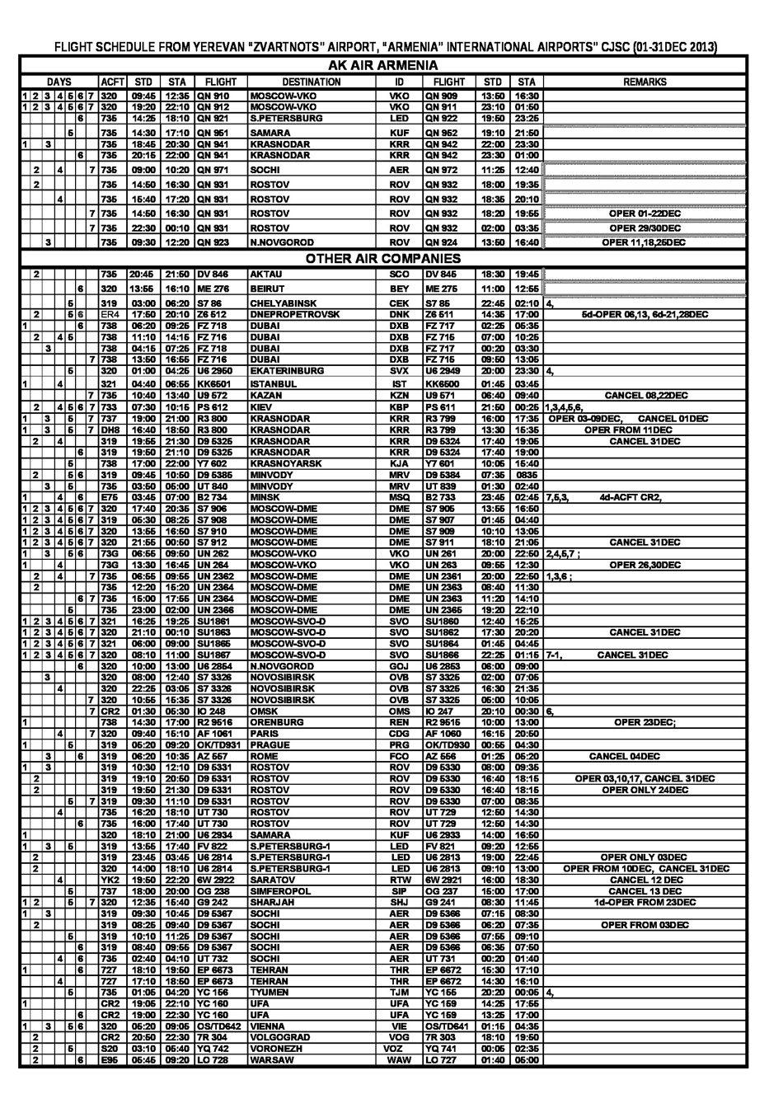
FLIGHT SCHEDULE FROM YEREVAN “ZVARTNOTS” AIRPORT, “ARMENIA” INTERNATIONAL AIRPORTS” CJSC (27OCT-30NOV 2013)

AK AIR ARMENIA
DAYS |  |  |  |  |  |  | ACFT | STD | STA | FLIGHT | DESTINATION | ID | FLIGHT | STD | STA | REMARKS
1 | 2 | 3 | 4 | 5 | 6 | 7 | 735 | 09:45 | 12:35 | ARR 910 | MOSCOW-VKO | VKO | ARR 909 | 13:50 | 16:30 | OPER FROM 27OCT
1 | 2 | 3 | 4 | 5 | 6 | 7 | 320 | 19:20 | 22:10 | ARR 912 | MOSCOW-VKO | VKO | ARR 911 | 23:10 | 01:50 | OPER FROM 17NOV
 |  |  |  |  | 6 |  | 735 | 14:25 | 18:10 | ARR 921 | S.PETERSBURG | LED | ARR 922 | 19:50 | 23:25 | OPER FROM 16NOV
 |  |  |  | 5 |  |  | 735 | 14:30 | 17:10 | ARR 951 | SAMARA | KUF | ARR 952 | 19:10 | 21:50 | OPER FROM 15NOV
1 |  | 3 |  |  | 6 |  | 735 | 07:55 | 09:30 | ARR 941 | KRASNODAR | KRR | ARR 942 | 11:00 | 12:30 | OPER FROM 16NOV
 | 2 |  | 4 |  |  | 7 | 735 | 09:00 | 10:20 | ARR 971 | SOCHI | AER | ARR 972 | 11:25 | 12:40 | OPER FROM 17NOV
 | 2 |  |  |  |  |  | 735 | 14:50 | 16:30 | ARR 931 | ROSTOV | ROV | ARR 932 | 18:00 | 19:35 | OPER FROM 19NOV
 |  |  | 4 |  |  |  | 735 | 15:40 | 17:20 | ARR 931 | ROSTOV | ROV | ARR 932 | 18:35 | 20:10 | OPER FROM 21NOV
 |  |  |  |  |  | 7 | 735 | 14:50 | 16:30 | ARR 931 | ROSTOV | ROV | ARR 932 | 18:20 | 19:55 | OPER FROM 17NOV

OTHER AIR COMPANIES
 | 2 |  |  |  |  |  | 735 | 20:45 | 21:50 | DV 846 | AKTAU | SCO | DV 845 | 18:30 | 19:45
 |  |  |  |  | 6 |  | 320 | 13:55 | 16:10 | ME 276 | BEIRUT | BEY | ME 275 | 11:00 | 12:55
 |  |  |  | 5 |  |  | 319 | 03:00 | 06:20 | S7 86 | CHELYABINSK | CEK | S7 85 | 22:45 | 02:10 | 4,
 | 2 |  |  | 5 |  |  | ER4 | 17:50 | 20:10 | Z6 512 | DNEPROPETROVSK | DNK | Z6 511 | 14:35 | 17:00 | 5d-OPER FROM 15NOV
1 |  |  |  |  | 6 |  | 738 | 06:20 | 09:25 | FZ 718 | DUBAI | DXB | FZ 717 | 02:25 | 05:35
 | 2 |  | 4 | 5 |  |  | 738 | 11:10 | 14:15 | FZ 716 | DUBAI | DXB | FZ 715 | 07:00 | 10:25
 |  | 3 |  |  |  |  | 738 | 04:15 | 07:25 | FZ 718 | DUBAI | DXB | FZ 717 | 00:20 | 03:30
 |  |  |  |  |  | 7 | 738 | 13:50 | 16:55 | FZ 716 | DUBAI | DXB | FZ 715 | 09:50 | 13:05
 |  |  |  | 5 |  |  | 320 | 01:00 | 04:25 | U6 2950 | EKATERINBURG | SVX | U6 2949 | 20:00 | 23:30 | 4,
1 |  |  | 4 |  |  |  | 321 | 04:40 | 06:55 | KK6501 | ISTANBUL | IST | KK6500 | 01:45 | 03:45
 |  |  |  |  |  | 7 | 735 | 10:40 | 13:40 | U9 572 | KAZAN | KZN | U9 571 | 06:40 | 09:40
 | 2 |  | 4 | 5 | 6 | 7 | 733 | 07:30 | 10:15 | PS 612 | KIEV | KBP | PS 611 | 21:50 | 00:25 | 1,3,4,5,6,
1 | 2 | 3 | 4 | 5 |  | 7 | DH8 | 16:40 | 18:50 | SYL 800 | KRASNODAR | KRR | SYL 799 | 13:30 | 15:35
 |  |  |  |  | 6 |  | DH8 | 15:40 | 17:50 | SYL 800 | KRASNODAR | KRR | SYL 799 | 12:30 | 14:35
 | 2 |  | 4 |  |  |  | 319 | 20:10 | 21:30 | D9 5325 | KRASNODAR | KRR | D9 5324 | 17:40 | 19:00 | 4d-OPER FROM 07NOV
 |  |  |  |  | 6 |  | 319 | 19:50 | 21:10 | D9 5325 | KRASNODAR | KRR | D9 5324 | 17:40 | 19:00
 |  |  |  | 5 |  |  | 738 | 17:00 | 22:00 | Y7 602 | KRASNOYARSK | KJA | Y7 601 | 10:05 | 15:40
 | 2 |  |  | 5 | 6 |  | 319 | 09:45 | 10:50 | D9 5385 | MINVODY | MRV | D9 5384 | 07:35 | 0835
 |  | 3 |  | 5 |  |  | 735 | 03:50 | 05:00 | UT 840 | MINVODY | MRV | UT 839 | 01:30 | 02:40
1 |  |  | 4 |  | 6 |  | E75 | 03:45 | 07:00 | B2 734 | MINSK | MSQ | B2 733 | 23:45 | 02:45 | 7,5,3, 4d-ACFT CR2
1 | 2 | 3 | 4 | 5 | 6 | 7 | 320 | 17:40 | 20:35 | S7 906 | MOSCOW-DME | DME | S7 905 | 13:55 | 16:50
1 | 2 | 3 | 4 | 5 | 6 | 7 | 319 | 05:30 | 08:25 | S7 908 | MOSCOW-DME | DME | S7 907 | 01:45 | 04:40
1 | 2 | 3 | 4 | 5 | 6 | 7 | 320 | 13:55 | 16:50 | S7 910 | MOSCOW-DME | DME | S7 909 | 10:10 | 13:05
1 | 2 | 3 | 4 | 5 | 6 | 7 | 320 | 21:55 | 00:50 | S7 912 | MOSCOW-DME | DME | S7 911 | 18:10 | 21:05
1 |  | 3 |  | 5 | 6 |  | 735 | 06:55 | 09:50 | UN 262 | MOSCOW-VKO | VKO | UN 261 | 20:00 | 22:50 | 2,4,5,7 ;
1 |  |  | 4 |  |  |  | 738 | 13:30 | 16:45 | UN 264 | MOSCOW-VKO | VKO | UN 263 | 09:55 | 12:30 | CANCEL 04,07NOV
 | 2 |  | 4 |  |  | 7 | 738 | 06:55 | 09:55 | UN 2362 | MOSCOW-DME | DME | UN 2361 | 20:00 | 22:50 | 1,3,6 ; CANCEL 02/03NOV
 | 2 |  |  |  |  |  | 738 | 12:20 | 15:20 | UN 2364 | MOSCOW-DME | DME | UN 2363 | 08:40 | 11:30
 |  |  |  |  | 6 | 7 | 738 | 15:00 | 17:55 | UN 2364 | MOSCOW-DME | DME | UN 2363 | 11:20 | 14:10
 |  |  |  | 5 |  |  | 738 | 23:00 | 02:00 | UN 2366 | MOSCOW-DME | DME | UN 2365 | 19:20 | 22:10
1 | 2 | 3 | 4 | 5 | 6 | 7 | 321 | 16:25 | 19:25 | SU1861 | MOSCOW-SVO-D | SVO | SU1860 | 12:40 | 15:25
1 | 2 | 3 | 4 | 5 | 6 | 7 | 320 | 21:10 | 00:10 | SU1863 | MOSCOW-SVO-D | SVO | SU1862 | 17:30 | 20:20
1 | 2 | 3 | 4 | 5 | 6 | 7 | 321 | 06:00 | 09:00 | SU1865 | MOSCOW-SVO-D | SVO | SU1864 | 01:45 | 04:45
1 | 2 | 3 | 4 | 5 | 6 | 7 | 320 | 08:10 | 11:00 | SU1867 | MOSCOW-SVO-D | SVO | SU1866 | 22:25 | 01:15 | 7-1,
 |  |  |  |  | 6 |  | 320 | 10:00 | 13:00 | U6 2854 | N.NOVGOROD | GOJ | U6 2853 | 06:00 | 09:00
 |  | 3 |  |  |  |  | 320 | 08:00 | 12:40 | S7 3326 | NOVOSIBIRSK | OVB | S7 3325 | 02:00 | 07:05
 |  |  | 4 |  |  |  | 320 | 22:25 | 03:05 | S7 3326 | NOVOSIBIRSK | OVB | S7 3325 | 16:30 | 21:35
 |  |  |  |  |  | 7 | 320 | 10:55 | 15:35 | S7 3326 | NOVOSIBIRSK | OVB | S7 3325 | 05:00 | 10:05
 |  |  |  |  |  | 7 | CR2 | 01:30 | 05:30 | IO 248 | OMSK | OMS | IO 247 | 20:10 | 00:30 | 6, OPER FROM 02/03NOV
1 |  |  |  |  |  |  | 738 | 14:30 | 17:00 | R2 9516 | ORENBURG | REN | R2 9515 | 10:00 | 13:00 | OPER 28OCT,25NOV;
 |  |  |  |  |  | 7 | 320 | 09:40 | 15:10 | AF 1061 | PARIS | CDG | AF 1060 | 15:20 | 19:55 | 6; OPER ONLY 26/27OCT
 |  |  | 4 |  |  | 7 | 320 | 09:40 | 15:10 | AF 1061 | PARIS | CDG | AF 1060 | 16:15 | 20:50 | 3,6; OPER FROM 30/31OCT
1 |  | 3 |  | 5 |  |  | 319 | 05:20 | 09:20 | OK/TD931 | PRAGUE | PRG | OK/TD930 | 00:55 | 04:30
 |  | 3 |  |  | 6 |  | 319 | 06:20 | 10:40 | AZ 557 | ROME | FCO | AZ 556 | 01:25 | 05:20
1 |  | 3 |  |  |  |  | 319 | 10:30 | 12:10 | D9 5331 | ROSTOV | ROV | D9 5330 | 08:00 | 09:35
 |  |  |  | 5 |  | 7 | 319 | 09:30 | 11:10 | D9 5331 | ROSTOV | ROV | D9 5330 | 07:00 | 08:35
 |  |  | 4 |  |  |  | 735 | 16:20 | 18:10 | UT 730 | ROSTOV | ROV | UT 729 | 12:50 | 14:30
 |  |  |  |  | 6 |  | 735 | 16:00 | 17:40 | UT 730 | ROSTOV | ROV | UT 729 | 12:50 | 14:30
1 |  |  |  |  |  |  | 320 | 18:10 | 21:00 | U6 2934 | SAMARA | KUF | U6 2933 | 14:00 | 16:50
1 |  | 3 |  | 5 |  |  | 319 | 13:55 | 17:40 | FV 822 | S.PETERSBURG-1 | LED | FV 821 | 09:20 | 12:55
 | 2 |  |  |  |  |  | 320 | 23:45 | 03:45 | U6 2814 | S.PETERSBURG-1 | LED | U6 2813 | 19:30 | 22:45
 |  |  | 4 |  |  |  | YK2 | 19:50 | 22:20 | 6W 2922 | SARATOV | RTW | 6W 2921 | 16:00 | 18:30 | CANCEL 31OCT;14,28NOV
 | 2 |  |  | 5 |  | 7 | 320 | 12:35 | 15:40 | G9 228 | SHARJAH | SHJ | G9 227 | 08:30 | 11:45
 |  |  |  |  | 6 |  | 737 | 07:00 | 09:00 | OG238 | SIMFEROPOL | SIP | OG237 | 00:30 | 02:30 | OPER ONLY 01,08 NOV
 |  |  |  | 5 |  |  | 737 | 18:00 | 20:00 | OG238 | SIMFEROPOL | SIP | OG237 | 15:00 | 17:00 | FROM 15 NOV
1 |  | 3 |  |  |  |  | 319 | 09:30 | 10:45 | D9 5367 | SOCHI | AER | D9 5366 | 07:15 | 08:30
 |  |  |  | 5 |  |  | 319 | 10:10 | 11:25 | D9 5367 | SOCHI | AER | D9 5366 | 07:55 | 09:10
 |  |  |  |  | 6 |  | 319 | 08:40 | 09:55 | D9 5367 | SOCHI | AER | D9 5366 | 06:35 | 07:50
 |  |  | 4 |  | 6 |  | 735 | 02:40 | 04:10 | UT 732 | SOCHI | AER | UT 731 | 00:20 | 01:40
1 |  |  |  |  | 6 |  | 727 | 18:10 | 19:50 | EP 6673 | TEHRAN | THR | EP 6672 | 15:30 | 17:10
 |  |  | 4 |  |  |  | 727 | 17:10 | 18:50 | EP 6673 | TEHRAN | THR | EP 6672 | 14:30 | 16:10
 |  |  |  | 5 |  |  | 735 | 01:05 | 04:20 | YC 156 | TYUMEN | TJM | YC 155 | 20:20 | 00:05 | 4,
1 |  |  |  |  |  |  | CR2 | 19:05 | 22:10 | YC 160 | UFA | UFA | YC 159 | 14:25 | 17:55
 |  |  |  |  | 6 |  | CR2 | 19:00 | 22:30 | YC 160 | UFA | UFA | YC 159 | 13:25 | 17:00
1 |  | 3 |  | 5 | 6 | 7 | 320 | 05:20 | 09:05 | OS/TD642 | VIENNA | VIE | OS/TD641 | 01:15 | 04:35 | 7d-OPER ONLY 27OCT
 | 2 |  |  |  |  |  | CR2 | 20:50 | 22:30 | 7R 304 | VOLGOGRAD | VOG | 7R 303 | 18:10 | 19:50
 | 2 |  |  | 5 |  |  | S20 | 03:10 | 05:40 | YQ 742 | VORONEZH | VOZ | YQ 741 | 00:05 | 02:35
 | 2 |  |  |  | 6 |  | E95 | 05:45 | 09:20 | LO 728 | WARSAW | WAW | LO 727 | 01:40 | 05:00
